**Project**

**Improve Conference 2023**

Țurcanu Daniel,

Summary

**1.** **Short description 3**

**2.** **ToR 4**

**3.** **Requirements 5**

**3.1** **UI/UX - Colors 5**

**3.2** **Browsers, devices and resolutions 6**

**4.** **Web site structure 6**

**4.1** **Navigation Bar 6**

**4.2** **Main page 6**

**4.2.1** **First screen – Into 6**

**4.2.2** **About 7**

**4.2.3** **Speakers 8**

**4.2.4** **Schedule 9**

**4.2.5** **Partners 9**

**4.2.6** **Contacts 10**

**4.2.7** **Get ticket 10**

**5.** **Contact page 11**

**6.** **Speakers page 12**

**7.** **Project duration and timelines 13**

# **Short description**

Improve conference, this is a conference where there will be many outstanding developers who have recently started their journey after graduation. This conference is mainly intended for young people whose eyes are burning with desire to become a programmer but don't know what kind of programmer they want to be. This conference will bring together a number of people from this field who will each represent their own profession, frontend backend qa and others.

The conference is filled with interactivity and interaction with the audience, as well as coffee breaks. That's why our conference brings together a diverse panel of experts, each representing their own specialization. This allows attendees to gain valuable insights into different career paths and make informed decisions about their programming aspirations.

Participation is absolutely free of charge.The conference program will consist of basic things from each industry presented, so that a person can decide what he likes and what kind of programming he will choose.Some people like to see the result after the code - like Frontend, and some people want something more complicated and interesting, like Backend. And some people find programming very difficult but still want to be a part of this industry, then they will be interested to hear about QA Manual.

The conference will be a one-time event and will be sponsored by several IT companies, flyers will be given out after the conference to enter the internship.   
  
The highlight of the conference will be that the speakers do not have a lot of experience and age but already work consistently well in companies. This will be a motivation and direct proof that in 1-2 years a person can do the same.   
  
On the stage can also be invited audience members from the audience who have already started a little bit of this path and tell other participants in the audience how to better start learning programming in 2023. The main speaker will confirm his words if everything is right, otherwise he will tell people what is wrong.

The conference will be held on the evening of December 30 at the Chisinau Arena.

1. **ToR**

1. Project Overview:

This TOR outlines the requirements and objectives for the website design project.

The project aims to create a beautiful and attractive website for Improve Conference.

2. Objectives:

Develop a modern, responsive, and mobile-friendly website.

Facilitate online registration and ticketing for conference attendees.

Enhance participant interaction and engagement through online features.

Increase online visibility and brand recognition.

3. Scope of Work:

Provide clear and concise information about the conference schedule, speakers, and topics.

Ensure the website is accessible across various devices and browsers.

Design and develop a user-friendly and responsive website that reflects the conference's theme and brand.

4. Deliverables:

Fully functional website with attractive features.

High-resolution images and graphics used in the design.

5. Budget:

The budget for this project is 200 USD$.

Any additional costs beyond the agreed budget must be approved in advance.

6. Team Responsibilities:

Designs, develops, and maintains the website, ensuring it meets technical standards and user experience requirements.

Developer will take all responsibilities.

7. Approval Process:

Monthly meetings

8. Contact Information:

Țurcanu Daniel  
danileturcanu15@gmail,com

9. Confidentiality:

All project-related information and materials are considered confidential and should not be disclosed without proper authorization.

10. Terms and Conditions:

This TOR serves as a binding agreement between both sides.

11. Changes

The instructions contained herein are not intended to be exactly the same and may be changed at will and by agreement of both parties. The requirements shown below are only an idea, an example and a foundation that can be developed into other different directions.

12. Acceptance:

By signing below, both parties acknowledge their understanding and acceptance of the terms and conditions outlined in this TOR.

Client's Signature: ______________________________ Date: ________________

Developer’s Signature: ______________________ Date: ________________

# **Requirements**

## **aUI/UX - Colors**

Main colors:

* #C89AFC
* #DF5950
* Black and other shades of color
* gradient (optional)

## **Browsers, devices and resolutions**

Browsers:

* IE6
* Opera
* Google chrome

Devices:

* PC
* Mobile devices

Resolutions:

* PC
  + From full HD to 8K
* Mobile devices
  + Width from 300 to 600

# **Web site structure**

## **Navigation Bar**

The structure of nav bar will be like tihs

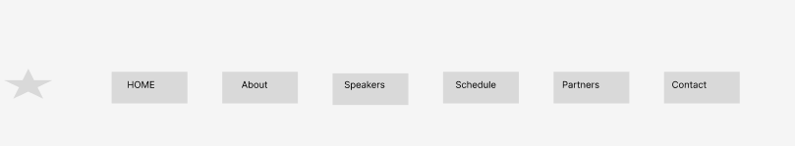

1. **Main page**

### **First screen – Into**

Something similar to this template <https://www.figma.com/file/hBBrWjcbx3J0Ykl7My7FGB/Templates-%2318.-More-on-Figma.info-(Copy)?type=design&node-id=10091%3A13&mode=dev>  
  
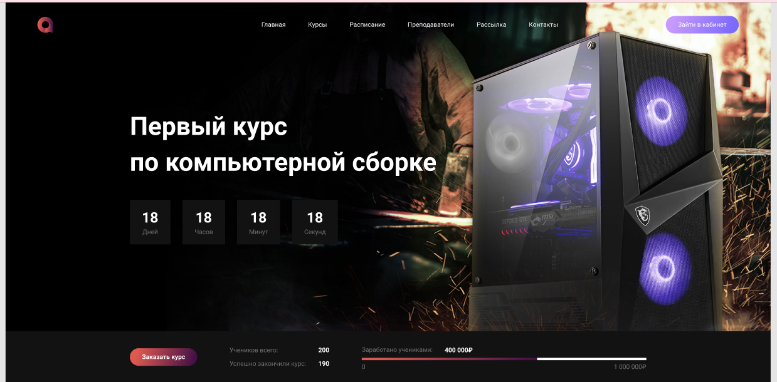

At the footer here will be total available places and reserved, and also button for get ticket

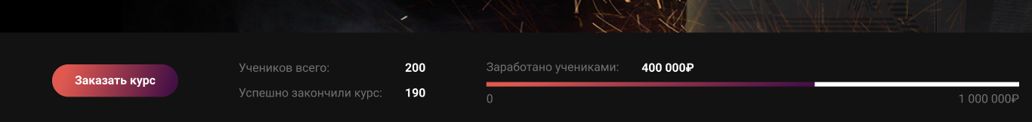

Wallpaper will be something associated to programming, timer will be seted to 30 december, text also will be about conference.  
Logo will be seted in container, not out.

Colors will be used as same here.

1. **About**

This section contain a short description about event. An image will be displayed away of information to attract people.

Similar like this  
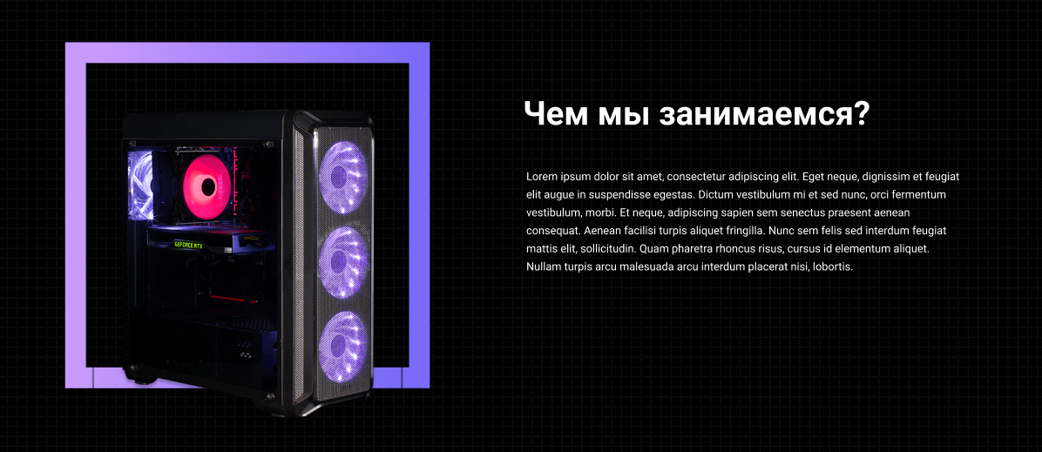

also, about section will consist one more about section, which will look like this  
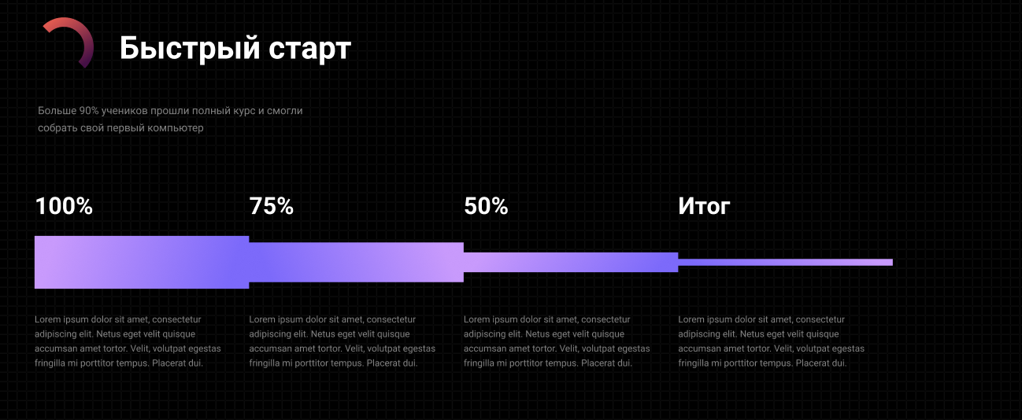  
Here will be something about programming in percentage, for example, percentage of how many people became developers from school to real work, their minds and thoughts about this profession. Only strong (it’s about psychology and goals) people become what they want to be. ( free choice, you can choose something by self).

And also 3 section at about, text will be indicated later, now use where is not indicated lorem ipsum.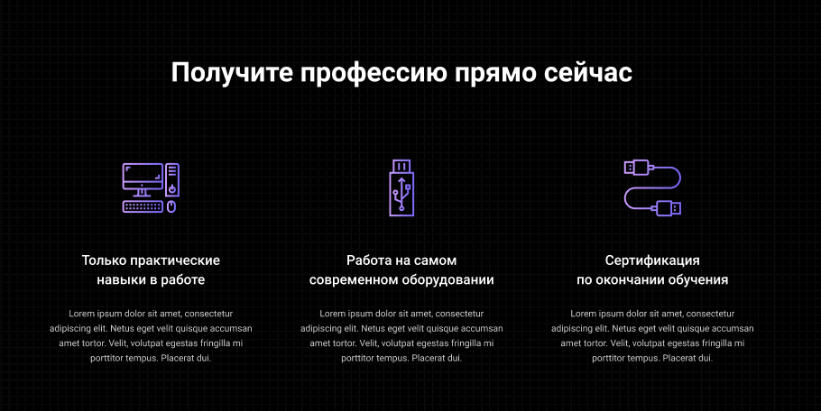

1. **Speakers**

This section contains the list of the speakers. Speakers will be displayed as shown below

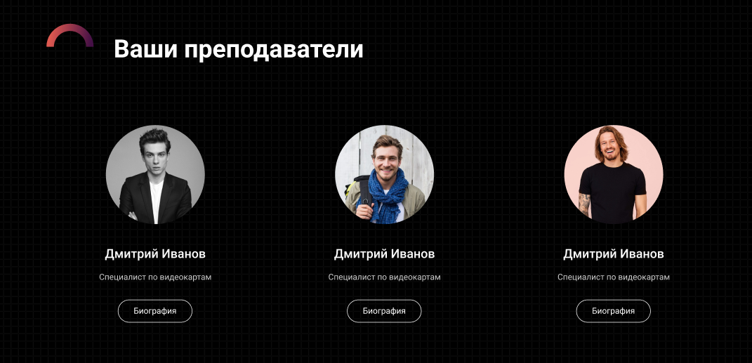

Each speaker item contains:

Photo

Speaker name

Speaker position

1. **Schedule**

Something similar to this site <https://bitconf.md/>

This section contains the list of the topics(presentations).

Topics will be displayed as shown below

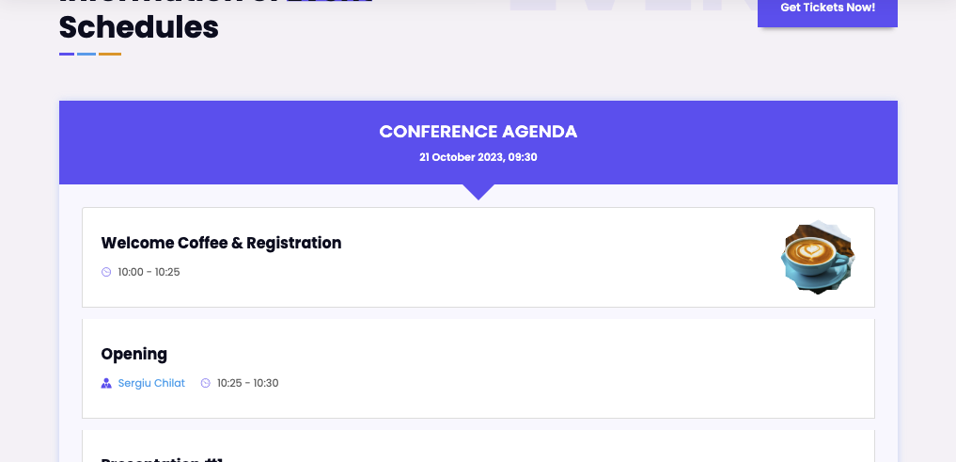

But it will be modified in our colors of project.  
Each topic item contains:

Subject

Speaker name

Start time - end time

Speaker photo

1. **Partners**

This section will contain a grid of companies image list with lines between them.  
Something like tihs  


Additional, when we hover our pointer to one company here will be animation (your choice)

1. **Contacts**

**This section will contain:**Email subscription for offers, and others  
Facebook, Instagram, LinkedIn, Twitter  
This section (footer) will be present at all other pages of website  
Something like this  
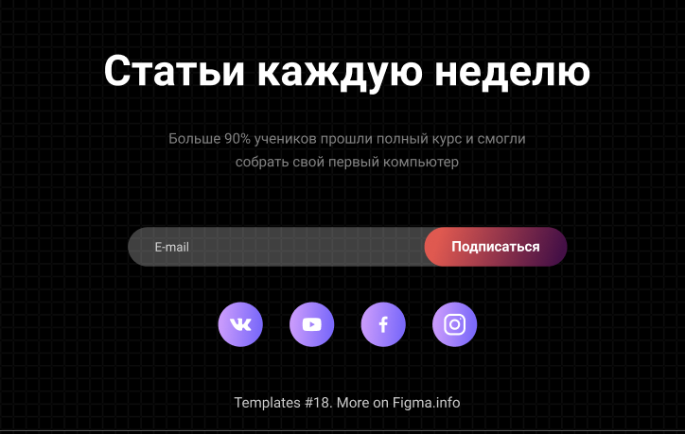

1. **Get ticket**

When we will press this button another page will be open with a form, where we need to complete with our data

This contains:

* Name
* Surname
* Email

Form will be similar like in Contact page but with these fields, which was indicated before

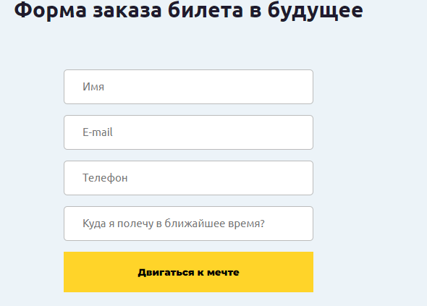

1. **Contact page**

There will be a page which contains the additional information for contact, fax, addres of event, phone. Here will be a embed google map with location of where will be event. Like this

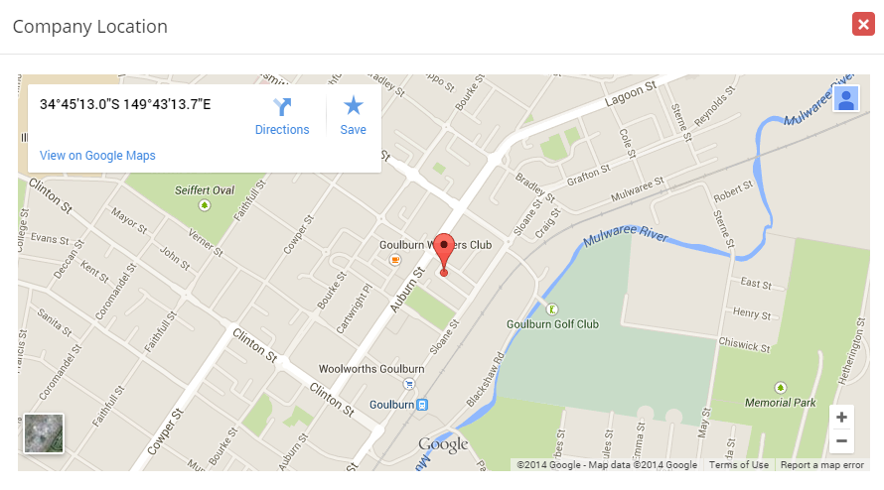

And contacts will be like this   
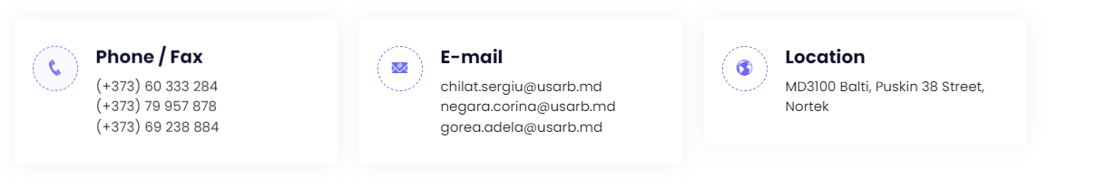

There also will be present form too, to contact us, like this

Form will be contains:

* Name  
  Email
* Phone number
* Message



1. **Speakers page**

This page will be contains the same info from main page but with extended information and little bit different design. There will be a short description about each speaker and their socials, including:

* github
* Linkedin
* Instagram
* Quote

Like this (need to use same color, and create beauty harmonic design, free choice)

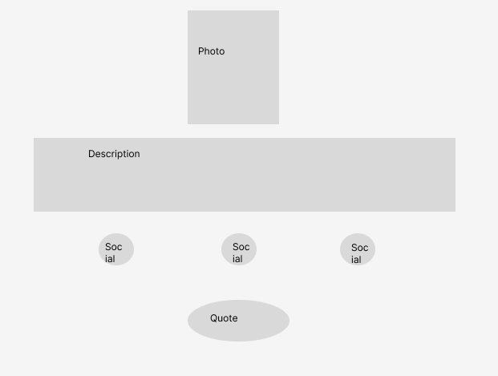

1. **Project duration and timelines**

Project will start: 20.10.2023

Project will end: 20.12.2023

Timeline for each sections.page is not specified, it’s free worktime, but website need to be done at timeline 20.12.2023